Merry Mou
December 7, 2015
STS.082

Planned Adaptivity in Internet Protocol Standardization

1 Introduction

The loosely organized and ever-evolving Internet is not governed by one central body. Among the structures in place to guide the Internet’s growth is the Internet Engineering Task Force (IETF), the organization responsible for the standardization of protocols used to facilitate communication within networks.

Founded upon the values of transparency, participatory openness, adaptability, and technical competence, IETF reaches rough consensus about best practices and standard protocols to the rest of the Internet community. These guiding values are necessary for the IETF’s success in influencing the rapid growth and open development of the Internet.

This paper will analyze the values, structures, and processes of the IETF, and how effective it is in providing for the past, present, and future needs of the Internet. The IETF, through its Internet Standards Process oversees the standardization of all protocols “above the wire and below the application”: in other words, the “core” or bulk of the protocols, which must be used for node-to-node communication. Among the protocols the IETF is responsible for is the TCP/IP suite, a set of protocols that the bulk of the Internet is built on top of in order to communicate with one another. To better understand the dynamics and role of standardization in Internet development, we will look at two specific cases: 1) the successful widespread implementation of the TCP/IP suite of protocols, and 2) the ongoing standardization of an instant messaging protocol XMPP.

2 Background

The Internet and the Internet Standards

The Internet is a communications infrastructure of global scale consisting of networks, or collections of computers and connections between those computers. These networks are minimally organized, autonomous, and interconnected. Computers within the network may communicate, or send and receive data to/from, with other computers via various technologies (such as telephone circuits and fiber optics). The Internet is designed for generality of use: in order for these various technologies, computers, applications running on computers (such as email, and the World Wide Web), and network configurations, to be compatible, various protocols and procedures have been designed to allow for computers to successfully exchange units of data with one another.

These protocols are defined by the Internet Standards. In general, an Internet Standard is “a specification that is stable and well-understood, is technically competent, has multiple, independent, and interoperable implementations with substantial operational experience, enjoys significant public support, and is recognizably useful in some or all parts of the Internet.”¹. The Internet Standards are overseen by the Internet Engineering Task Force (IETF). Often described as “open standards,” they are recommended, but not mandated or enforced, by the IETF.

For some historical perspective, the Internet can be approximated to have begun around the birth of ARPANet in 1967, a network that connected some research computers using telephone lines. Internet technical development reached its “golden age” in the 1980s; in 1983, the Transmission Control Protocol/Internet Protocol (TCP/IP) Suite, which is now considered a foundational suite of Internet Standards, was standardized and implemented across the entirety of what was the Internet then. The World Wide Web, which is a widely-used application that allows for distributed document storage, was invented in 1990.

Internet Organizations

No single governing group controls the Internet. Among the major players are ICANN (Internet Corporation for Assigned Names and Numbers), ISOC (The Internet Society), IETF (Internet Engineering Task Force), W3C (World Wide Web Consortium).

Various organizations define technical standards that help improve the interoperability, security, and quality of the Internet. These standards range from character encoding (by the Unicode Consortium) to application-level web protocols (by the W3C) to infrastructure design (by the IETF). As mentioned above, the IETF is of particular interest for its administration of the Internet Standards. IETF’s Internet Standards focus on protocols from the IP layer to up to the application layer. Note that even with the foundational importance of the Internet Standards, there are many other standards that impact the development and implementation of the Internet. The way that the IETF addresses some of these “external specifications” is described in the section 3 “The Internet Standards Process” below.

Internet Engineering Task Force (IETF)

Unlike most standardization organizations, the IETF is a voluntary and open group. Founded in 1986, it is a non-profit, international, self-organized group with no formal conception of membership. Most of its members are engineers (though anyone is welcome to join the mailing lists, where most discussion takes place); its focus is on the technical design of the Internet, and they “try to avoid policy and business questions, as much as possible.” IETF’s mission is to “make the Internet work better” by producing “high quality, relevant technical and engineering documents that influence the way people design, use, and manage the Internet.”.

The IETF is under the ISOC, an international, non-profit, membership group that helps “foster the expansion of the Internet” often through financial, legal, and political means. The IETF, which focuses on shorter-term standards-making, also interacts with the Internet Research Task Force (IRTF), which focuses on longer-term research initiatives. The ISOC does not have any jurisdiction over IETF’s standard-making processes.

The IETF is composed of working groups, which are divided by topic (such as routing, security, etc.). A majority of IETF’s work is done in these working groups, particularly on their mailing lists, which anyone can join. Working groups work to complete milestones and tasks outlined in their charters; their progress is facilitated by working group chairs, who are analogous to “technical managers.” Working group chairs are appointed by Area Directors in the Internet Engineering Steering Group (IESG, see Figure 1), the group within IETF responsible for technical management of the IETF.

The primary products of the IETF are documents called RFCs. RFCs stands for “Request for Comments,” which reflects their recognition of the ever-evolving nature of the Internet. These documents range from protocol standards to best practices to informative pieces (in fact, contrary to popular belief, most of the RFCs are not describing Internet Standards). There are at least 7500 RFCs to date, and they can be retrieved at this URL: https://www.rfc-editor.org.

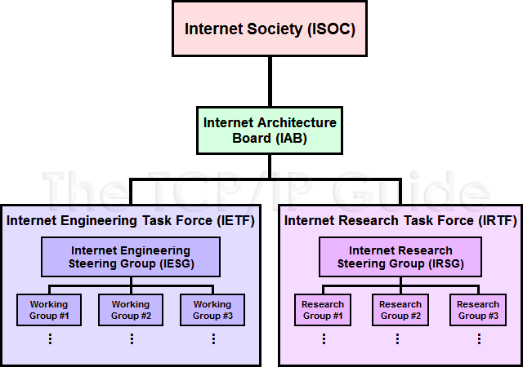
Figure 1. The structure of the IETF, in context of the ISOC and IRTF.

3 The Internet Standards Process

The Internet Standards Process is most recently defined in 1996 in RFC 2026, with several updates since then. (Beyond the scope of this paper, the Internet Standards Process RFC also discusses the intellectual property rights and copyright issues relevant to the standards process.) Anyone can access the current list of Internet Standards at the following URL: https://www.rfc-editor.org/standards.

The purpose of the Internet Standards Process is to define, evaluate, and adopt Internet Standards that are technically competent, sufficiently tested, and generally accepted by the community. The standardization process aims to be as simple as possible, in order to reduce confusion and process time and effort, without sacrificing quality and openness/fairness, which can often be conflicting goals. On paper, it is indeed a simplistic and general process that allows for the fair consideration of a wide range of technical specifications. It is flexible for (relatively) easy change, while giving ample time for evaluation and consensus-building.

All Internet Standards begin as an RFC. RFCs specifying some technical protocol/process may follow either the Standards Track, or the Non-Standards Track. Each track includes several maturity levels, which the technical specification may move through. The Standards Track currently includes the Proposed Standard and Internet Standard maturity levels. The Non-Standards Track includes the Experimental, Informational, and Historic maturity levels. RFCs with non-standard labels are not on track to become Internet Standards.

Focusing on the Standards Track, the Proposed Standard is the entry-level maturity, and is used to label specifications that are believed to be generally stable, well-understood, reviewed, and valued. At this stage, the specification does not necessarily have had to be implemented, but certainly implantation experience is helpful. Proposed Standards must remain at that level for at least 6 months, during which the specification is evaluated and may be revised. There is no algorithmic way in which specifications may progress through the Standards Track. Once the working group reaches rough consensus that the specification has reached a high level of technical maturity and adoption, and is widely believed to significantly benefit the Internet community, it may become an Internet Standard. All Internet Standards are labeled with an STD number (and still retains its RFC number).

Upon designating a new Internet Standard, IETF does not facilitate an adoption or implementation process. To allow for further adaptation, existing Internet Standards may be revised by progressing through the entire standardization process (again), as if it were a new standard. Internet Standards may also be retired to the label Historic (thus on the Non-Standards Track) if deemed obsolete.

The other two labels in the Non-Standards Track are Informational and Experimental. Informational specifications are published for purposes of education, and do not reflect consensus or recommendation by the IETF. Experimental specifications can be understood to be any protocol that is not an immediate candidate for Internet standardization. Such specifications may be under-analyzed or poorly understood, and they may significantly change, be replaced by another specification, or may never reach the Standards Track.

Some protocols, called “external specifications,” that the IETF chooses to adopt do not go through the Standards Track. The IETF identifies and addresses two categories of “external specifications”: open standards and vendor specifications. Open standards are technical specifications, such as the American National Standards Institute (ANSI) standard character set ASCII (encodes bit patterns to character symbols), are often “de jure” standards specified by accredited national and international standards bodies. Vendor specifications are “de facto” standards that have become widely adopted by the Internet community; they are typically not developed openly and are proprietary.

4 The Role of Standardization

The primary purpose of standardizing Internet protocols is to allow for interoperability. A secondary goal that also supplements the first is technical competence and quality (higher quality protocols are more likely to be interoperable). Most interestingly, no IETF Internet Standards are necessarily “enforced.” The IETF certainly does not enforce the implementation of any protocols, though it may recommend that some protocols, such as the virtually universally-used TCP/IP suite, to be “required” in its Applicability Statement for minimum interoperability.

The true incentive for entities to implement certain protocols is interoperability. With regards to the Internet, the truth of what is de facto “standard” is in the code: what computers have actually implemented. Interoperability, viewed as a collective action problem, does not suffer from the possibility of free-riding under-provided public goods, as the purpose of the Internet is to communicate with one another: the costs and benefits of implementing a protocol are essentially equal for all parties involved.

Thus, Internet Standards are not enforced by any top-down mechanisms. Consider the nature of the general-purpose Internet, a heterogeneous collection of connected computers. Anyone can create a network of computers that talk to one another using any protocol, but in order for this local network to access almost any other computer in the Internet, it must implement common protocols. Standardization of Internet protocols allows the Internet to be the network it is. We will look at how TCP/IP, the fundamental suite of Internet protocols, gained popularity in the beginnings of the Internet in the section 6 under “The Standardization and Adoption of the TCP/IP Suite” below, as a successful case of adaptive standardization of Internet protocols.

The IETF, as a non-profit and open organization, has minimal systematic biases against the public good of a technically sound and cooperative Internet. The open membership of the working groups has various effects. For the sake of open communication, a lot correspondence occurs not in person or in meetings but on mailing lists. This characteristic reflects the IETF’s value of transparency. In addition, because there is no formal membership, there is no formal voting during meetings; decisions are made via “rough consensus.” The idea of “rough consensus” originates from an early quote about IETF’s founding principles from David Clark: "We reject kings, presidents and voting. We believe in rough consensus and running code." This reflects IETF’s deference to technology, both in upholding technical competence and adapting to rapid technological change.

The open membership motivates various systematic delays (which allow sufficient review time), and causes various systemic delays (in the process of trying to achieve rough consensus). While delays can impede progress and be frustrating from a morale standpoint, IETF standardization is a process that is more harmed by premature standardization than delayed standardization. As a mere recommender of open protocols, the IETF is not incentivized to create more standards than it needs to; instead, by only standardizing protocols that are agreed to technically sophisticated and widely beneficial, the IETF facilitates better, simpler Internet design, as well as maintains credibility.

Because the protocols are not enforced, a large role of the IETF is to serve as the public “bulletin board” that allows for dissemination of credible information. While protocols go through extensive testing and technical review before becoming Internet Standards, they still have various pros and cons. In fact it is important to recognize that it is difficult to identify, specify, and adopt an objectively “best” protocol design. A protocol may be designed to be more secure, flexible, functional, performant, or have some other quality. In addition, deciding the “best” protocol is only part of the issue, as the IETF is also interested in standardizing protocols that have been proven to be implemented, tested, and adopted in multiple different network environments. Often, the specifications that are adopted in practice are not theoretically superior; many other factors, including ease of installation, adaptability, convenience, and development community, affect whether a certain protocol is adopted.

An interesting feature of the IETF’s standardization scheme is that it allows for the designation of Experimental specifications, which are specifications that are not immediately in consideration to become Internet Standards. RFCs that describe Experimental specifications educate the Internet community about new technologies and methods, and they may be implemented, tested and tweaked by individuals and sub-networks. An Experimental specification may later become a Proposed Standard, and thus be on track to become an Internet Standard, if deemed appropriate. Thus the label allows for a wide range of consideration and experimentation (so to speak) for standardization. Even specifications that remain experimental may be implemented globally for specific purposes. Again, the IETF here serves as a “bulletin board” to best disseminate best practices and knowledge to allow for interoperability.

The IETF’s focus on recommending often the most tried and tested protocols indicates its prioritization of practicality. Disregarding the objective superiority of the standardized protocols, the standardization process accomplishes to recommend general, known best practices that all parties can refer to. Thus, the standardization process achieves its goal of interoperability.

5 Overall analysis of Internet Standards Process

At the present there are 69 Internet Standards (as there are 69 distinct STD numbers; some standards have multiple RFCs marked with the same STD number), and 2519 proposed standards.

Figure 2 is a current snapshot of the number of STDs (Internet Protocols) for each year. It is important to note that new RFCs often cause older RFCs to be obsolete; this graph does not trace back RFCs to their “earliest version.”

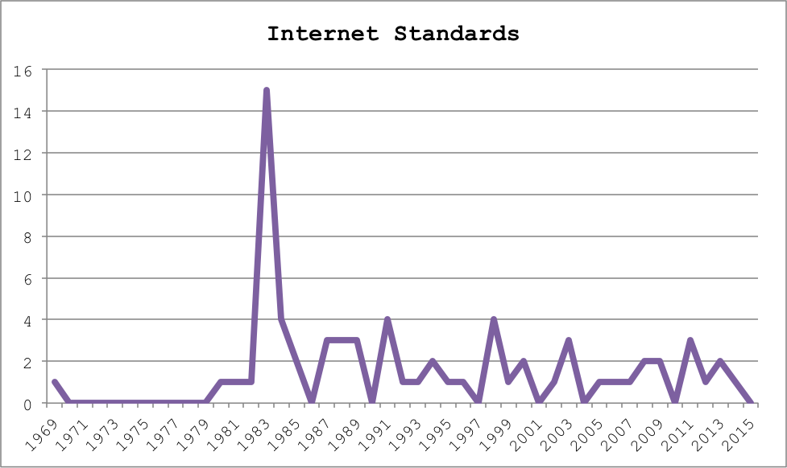
Figure 2. The Internet Standards, aggregated by their RFC date.

Figure 3 graphs the number of Proposed Standards for each year. The number of Proposed Standards has increased significantly in the past decade or so. Note the graph does not show how many protocols ever were Proposed Standards in a given year, only the number of protocols that are Proposed Standards right now in a given year. Therefore the exponential increase in proposals from around 1995 to a spike in 2006 could either be due to 1) an explosive increase in new specifications being proposed (what it may appear to look like at first glance), 2) an explosive output of revisions and work on existing proposals (thus reducing RFC counts for earlier years), or 3) an . Still, it is difficult to ignore the factors of the increasing size of the Internet, the increasing size of interested communities, as well as the increased research efforts with the growing complexity of infrastructure.
Figure 3. The proposed standards, aggregated by their RFC date (Internet Standards plotted as well for reference.

The process of standardization is slow but study. This may be for good reason. The goal is not to standardize as many protocols as possible. In fact, considering the non-mandatory nature of standardized protocols, is better to standardize fewer rather than more protocols, for the sake of quality and simplicity.

Some impediments to the process are described in RFC 1310:

“In practice, the process is somewhat more complicated, due to (1) the number and type of possible sources for specifications; (2) the need to prepare and revise a specification in a manner that preserves the interests of all of the affected parties; (3) the importance of establishing widespread community agreement on its technical content; and (4) the difficulty of evaluating the utility of a particular specification for the Internet community. Some specifications that are candidates for Internet standardization are the result of organized efforts directly within the Internet community; others are the result of work that was not originally organized as an Internet effort, but which was later adopted by the Internet community.”

There is no systematic process through which a proposed specification becomes an Internet Standard. This flexibility allows for working groups to properly and specifically assess the quality and relevance of each specification, including “external specifications” that did not originate from an initial RFC. The process is also subject to significant delays, as described in the quote, in the process of reaching an agreement.

While complex organizations often acquire inefficiencies to just function at all, the IETF’s open membership of individuals (as opposed to representatives from corporations/organizations) help decrease such systemic inefficiencies. Individuals participating in working groups have less complicated incentives, and are usually not negotiating with as high tangible stakes; there is no incentive for standardizing certain specifications due to possible profits that could be subsequently gained. The open membership of the working group also allows for members to balance one another’s needs and wants; the incentive to participate at all is often, for the mostly technically-minded members, to encourage high quality of technical development. To ensure that progress is made, a working group chair facilitates and moderates all meetings according to the working group’s charter. In addition, the concept of “rough consensus” also allows for some wiggle room in stagnant situations.

6 Case studies of Protocol Standardization and Adoption

The Standardization and Adoption of the TCP/IP Suite

The collective adoption of TCP/IP Suite, the set of protocols that make up the core of the Internet as we know it today, was probably the first sign that the Internet’s “belief in code” and open membership and adoption were important characteristics for the Internet’s success. In the early days of the Internet around 1980, another set of standards, Open Systems Interconnection (OSI) were being developed and supported by large institutions, including the US government.

Due to extensive involvement by many large interested players, the overhead of organizational processes significantly dragged progress. Meanwhile, proponents of the Internet Standards (that would be overseen by the IETF), including Dave Clark, emphasized non-threatening, informal working groups that consulted broadly (hence the usage of RFCs, or “Requests for Comment”) and adaptive and delayed standardization processes. Using this completely opposite approach, the Internet Standards were able to move quickly while attention was on OSI and its proponents. With sufficient uptake, ARPANet (which was the “Internet” back then) took a flag day in 1983 to retire the ARPANet host protocol, replacing it with the TCP/IP suite.

While the proponents of TCP/IP were busy doing and testing, the committees of OSI were bogged down by over-bureaucratization. While the U.S. Department of Commerce mandates in 1988 that government agencies purchase OSI-compliant products, more and more technologies and protocols were being actively built on top of TCP/IP, including the World Wide Web, released in 1991.

Technological progress “on the ground,” as opposed to top-down regulation, was, and seems to continue to be, the de facto necessity of the Internet. The underlying principles that enabled the TCI/IP suite to be implemented, tested, and distributed, persist to this day, as the IETF continues to use open working groups to recommend sufficiently technically detailed and and tested protocols for the Internet community.

The Standardization and Adoption of XMPP

Instant messaging, though a technology and concept that predates the Internet, has yet to have an open protocol considered an Internet Standard. The Extensible Messaging and Presence Protocol (XMPP), is a Proposed Standard most recently described in March 2011, which was first proposed in October 2004.

Most applications that have implemented instant messaging, such as Google, do not use XMPP for various technical and product reasons. Using XMPP confines the application to the technical constraints and features of the XMPP protocol, and also doesn’t allow the product to establish competitive advantage by locking in users to their service.

However consider that the majority of emails sent via the Internet use the Simple Mail Transfer Protocol (SMTP). This is what allows one to send emails between different clients (such as between Google and Yahoo). SMTP became an Internet Standard in March 2011, after first becoming a Proposed Standard in February 1993.

One could imagine a future where one could send instant messages between different clients, just as email. It is unclear when or whether XMPP will become an Internet Standard, especially considering that applications today are not incentivized to be cross-platform compatible, and “true standardization” happens at actual implementation. Given the relative young age of the XMPP RFC, XMPP likely will need to undergo further evaluation and testing to determine the extent of the benefits it brings to the Internet community.

8 Conclusion

The IETF Internet Standards Process reflects the nature of the Internet. Transparency, participatory openness, and adaptability have allowed the IETF to remain a relevant standardization administrator for the past four decades.

Since its inception, Internet’s wild growth has been enabled by its autonomous and loosely-organized nature. But another essential contributor to the Internet’s spread is the dissemination of best practices and standard protocol specifications, in order to allow for interoperability between different moving parts. The unprecedented global and evolving nature of the Internet calls for new regulatory mechanisms that also emphasize acknowledgement of change, uncertainty, and scale. The IETF’s structural organization, which includes working groups, and the Internet Standards Process, are prime example of adaptive decision-making processes.

On the question of regulation of a sprawling infrastructure as the Internet, the IETF itself divorces itself from the “problem” of enforcement. But to them, this is “not a bug, but a feature” (as they say in software development): the standards that become more widely implemented become more attractive for developers to implement, for the sake of interoperability with the rest of the Internet. In this way, the Internet does not require top-down enforcement, as technical competence will naturally lead to common best practices, most likely outlined by the IETF.

In the future, the IETF and other Internet organizations will need to adapt to the increased size and complexity of the Internet, in order to maintain the open and collaborative culture that the IETF is known for. It may be a helpful regulatory exercise to better define the quality of “openness,” and to continually monitor the openness of the organization’s operations as it grows.

In assessing the IETF’s success, it is important to recognize that the IETF does not strive to, or achieve, the “optimal” solutions for the Internet. As the OSI case indicates, the Internet will not result from careful and stifling planning and negotiation; the Internet will be built from the ground up, and the technologies that see the most uptake will gain recognition. Seeing that regulatory clamp-down is definitely not the answer, and would turn the values of the IETF on its head, the continued experiment will be what the IETF has already been doing: open working groups, rough consensus, and deference to the advancement and evolution of technology.

S. Bradner, “RFC 2026: The Internet Standards Process – Revision 3”, http://www.rfc-editor.org/info/rfc2026.
B. Leiner, “Brief History of the Internet”, http://www.internetsociety.org/internet/what-internet/history-internet/brief-history-internet.
“Getting Started in the IETF”, http://www.ietf.org/newcomers.html
H. Alvestrand, “A Mission Statement for the IETF”, http://www.rfcreader.com/#rfc3935.
P. Hoffman, “The Tao of IETF”, https://www.ietf.org/tao.html.
Taken from Figure 7: Internet Standards Organizations, C. Kozierok, http://www.tcpipguide.com/free/diagrams/funinternetstandards.png.
S. Bradner, “RFC 2026: The Internet Standards Process – Revision 3”, http://www.rfc-editor.org/info/rfc2026.
Official Internet Protocol Standards, https://www.rfc-editor.org/standards.php.
L Chapin, “The Internet Standards Process”, http://www.rfc-editor.org/info/rfc1310.
A. Russell, "OSI: The Internet That Wasn’t", http://spectrum.ieee.org/computing/networks/osi-the-internet-that-wasnt.
P. Saint-Andre, "Extensible Messaging and Presence Protocol (XMPP): Core", https://www.rfc-editor.org/rfc/rfc6120.txt.
P. Saint-Andre, "Extensible Messaging and Presence Protocol (XMPP): Core", http://www.rfc-editor.org/info/rfc3920.
S. Vaughan-Nichols, "Google moves away from the XMPP open-messaging standard", http://www.zdnet.com/article/google-moves-away-from-the-xmpp-open-messaging-standard.
J. Klensin, N. Freed, M. Rose, D. Crocker, Ed., "SMTP Service Extension for 8-bit MIME Transport", http://www.rfc-editor.org/info/std71.
J. Klensin, N. Freed, Ed., M. Rose, E. Stefferud, D. Crocker, "SMTP Service Extension for 8bit-MIMEtransport", http://www.rfc-editor.org/info/rfc1426

